Tjelesna i zdravstvena kultura
- VJEŽBE ZA RUKE ( BICEPS + TRICEPS ) + RAMENA + PRSA
SKLEKOVI  https://www.youtube.com/watch?v=FU_5LPjtjus | 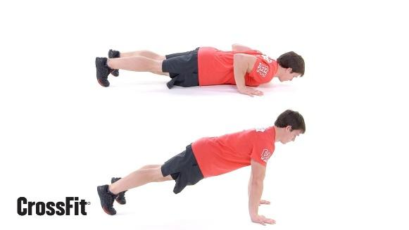
Spiderman sklek  https://www.youtube.com/watch?v=P4qR2p-bbAA&feature=youtu.be | 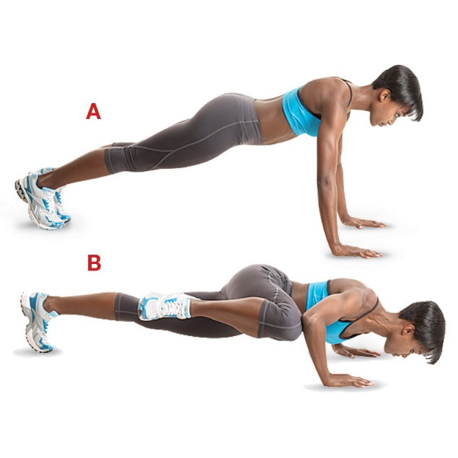
Plank s podizanjem na ruke  https://youtu.be/L4oFJRDAU4Q | 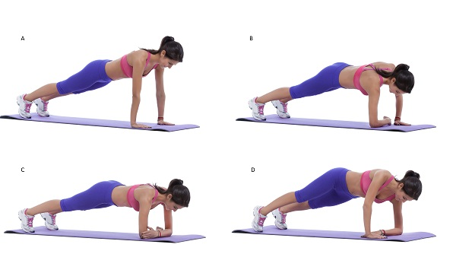
Odrucenje-za ramena  https://youtu.be/UzuWnV9SYJI | 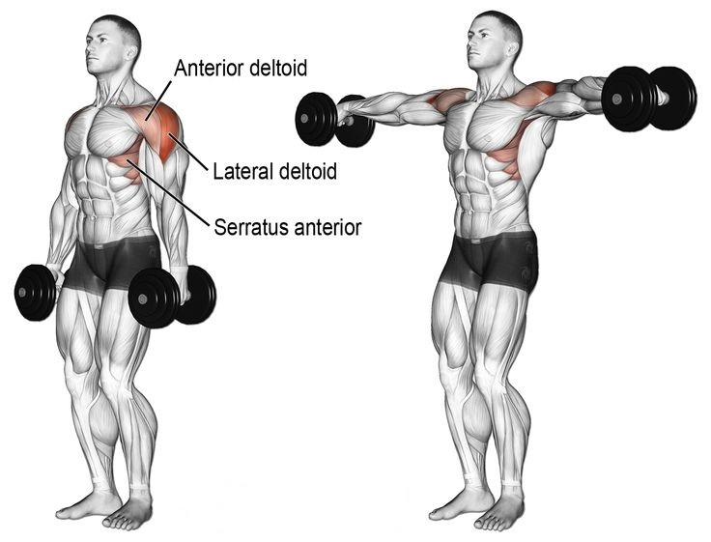
Bench Barbell Press  https://www.youtube.com/watch?v=rT7DgCr-3pg | 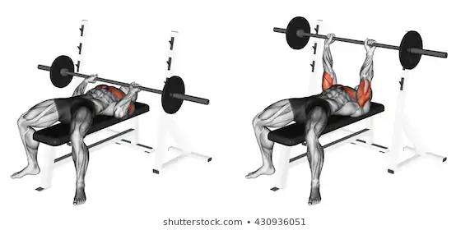
sklekovi strijelaca  https://www.youtube.com/watch?v=A0r8ploEnZY | 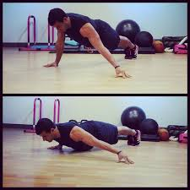
sklek sa jednom rukom  https://www.youtube.com/watch?v=edoINNsVu8Q | 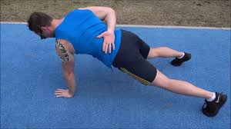
Triceps dips  https://www.youtube.com/watch?v=6kALZikXxLc | 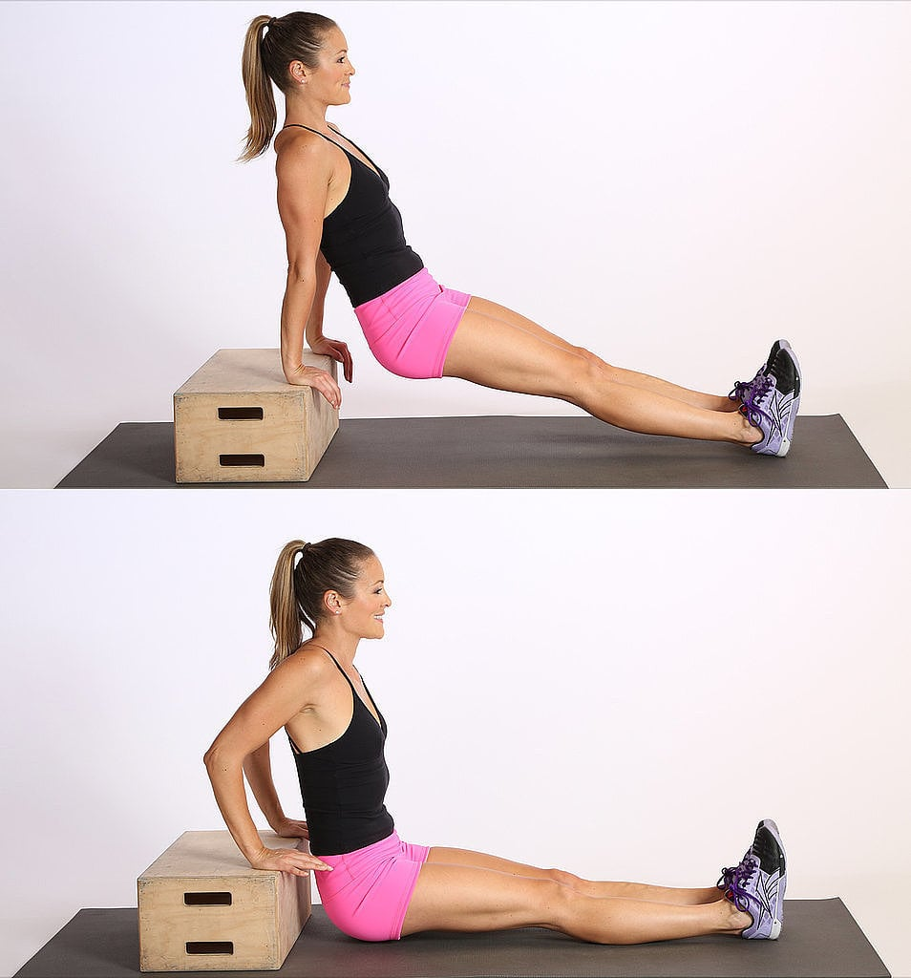
typewriter pushups  https://www.youtube.com/watch?v=fw56EiZYvm8 | 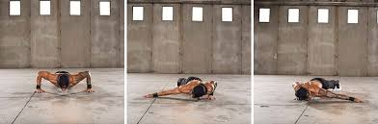
Triceps kicker  https://www.youtube.com/watch?v=X70Xh7vf5GU | 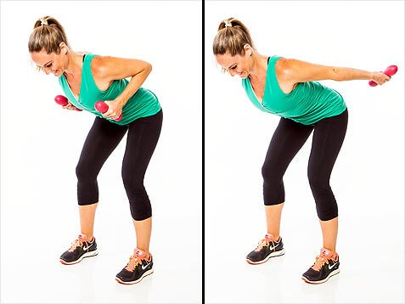
diamond pushups  https://www.youtube.com/watch?v=J0DnG1_S92I | 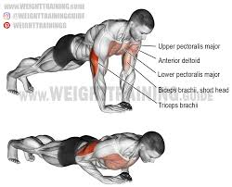
wide pushups  https://www.youtube.com/watch?v=rr6eFNNDQdU | 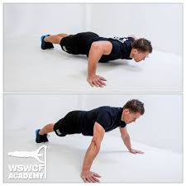
handstand pushups  https://www.youtube.com/watch?v=uZWjFe4fufA | 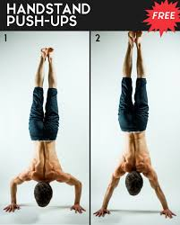
Sklek na povišenoj podlozi  https://m.youtube.com/watch?v=JJLx9xK1QV0 | 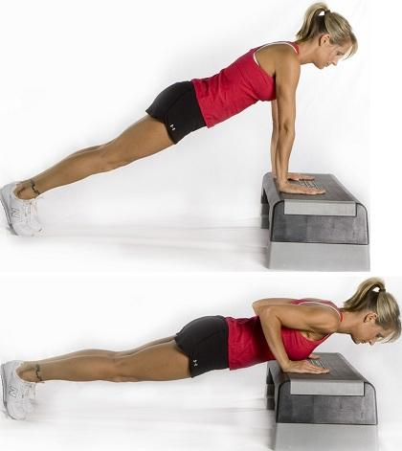
Triceps extensions  https://youtu.be/YbX7Wd8jQ-Q | 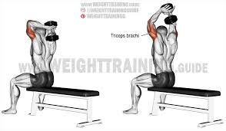
Plank s rotacijom  https://youtu.be/VBd6DBVNUYg | 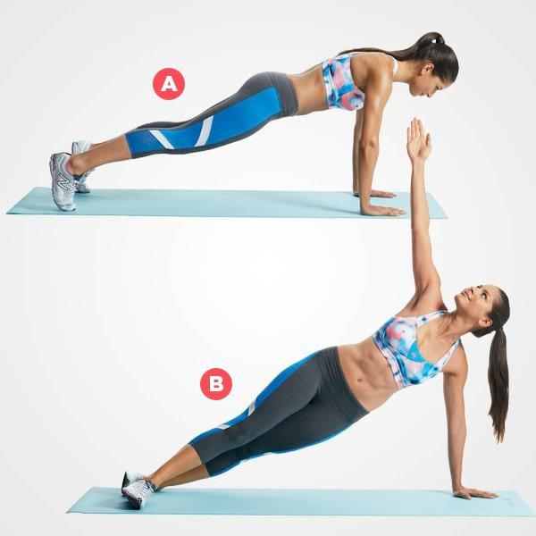
Predručenje s bučicama  https://www.youtube.com/watch?v=D-3JnFrFUOw | 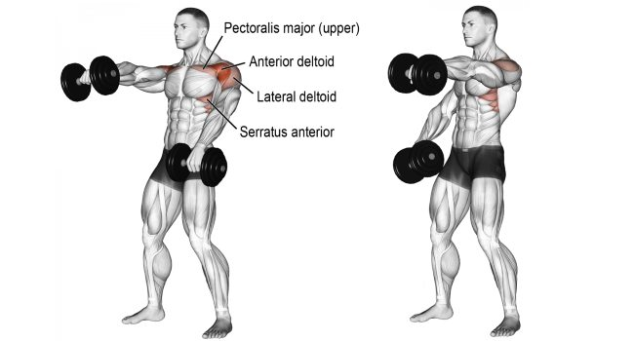

VJEŽBE ZA MIŠIĆE LEĐA (GORNJI DIO LEĐA + DONJI DIO LEĐA)

SUPERMAN  https://www.youtube.com/watch?v=VUT1RHyMEuc | 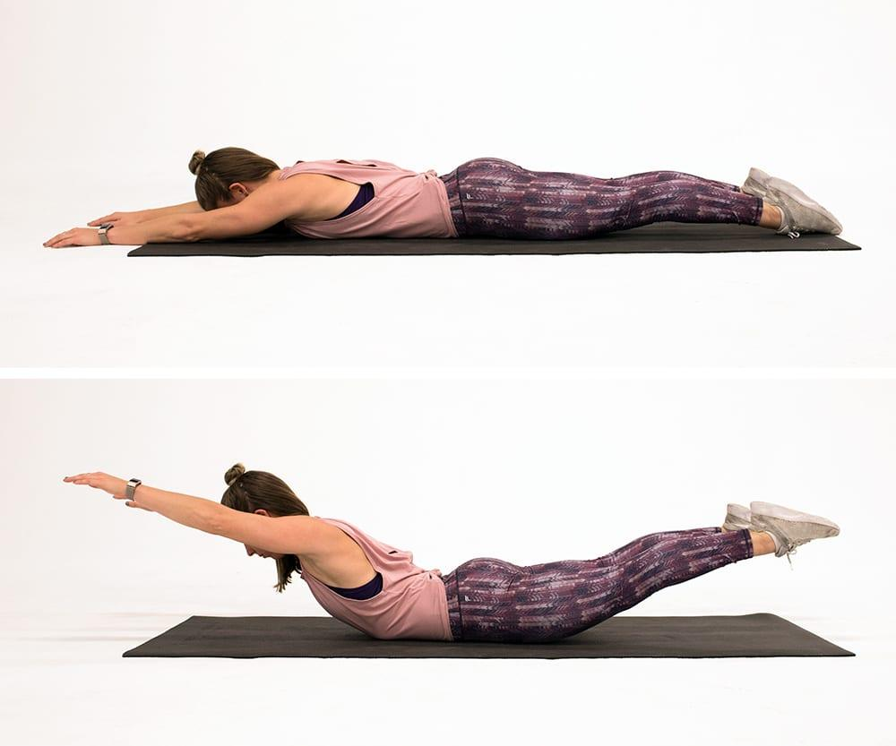
zgibovi  https://www.youtube.com/watch?v=eGo4IYlbE5g | 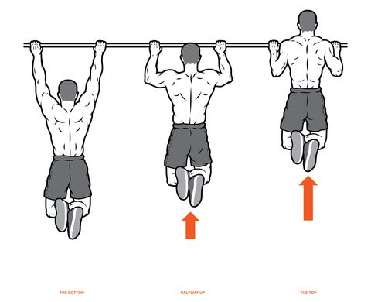
dumbell rows  https://www.youtube.com/watch?v=-koP10y1qZI | 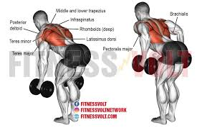
Uzručenje štapom iz pretklona | 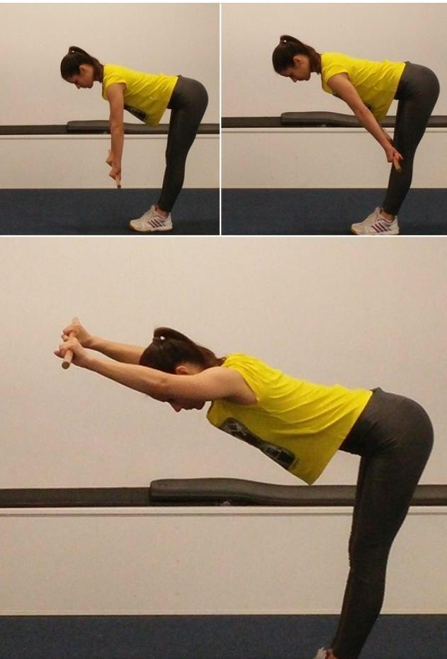
REVERSE SNOW ANGEL  https://www.youtube.com/watch?v=U06ntesBeX4 | 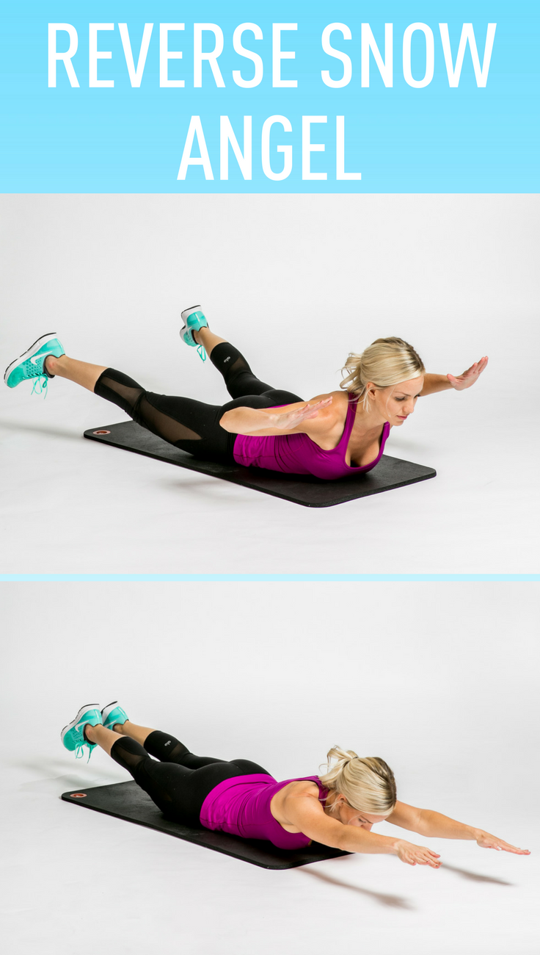
Elastic band row  https://www.youtube.com/watch?v=GCZ2r9Og_ek | 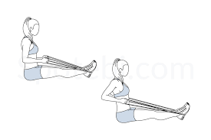
Lateral raise with dumbells  https://www.youtube.com/watch?v=Wz1C8NzWg5A | 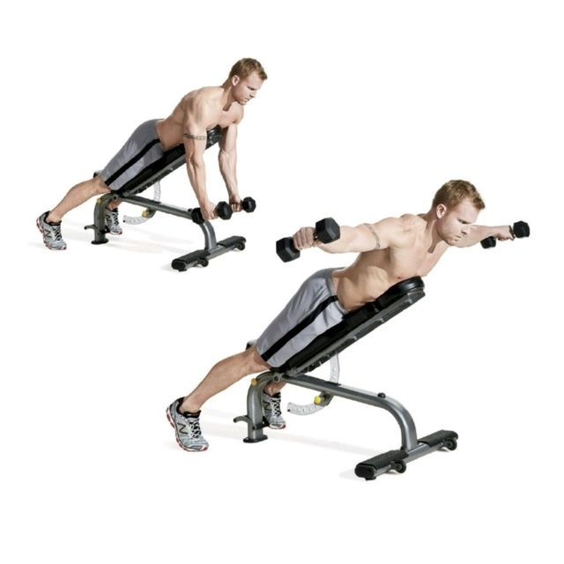
Band pull apart  https://www.youtube.com/watch?v=3OYSIWaJJk4 | 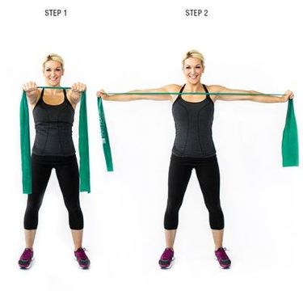
Bird dog  https://www.youtube.com/watch?v=wiFNA3sqjCA | 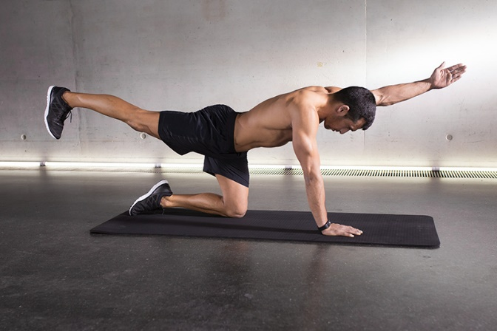

VJEŽBE ZA MIŠIĆE TRBUHA ( PREDNJA, BOČNA I STRAŽNJA STRANA)

DEAD BUG  https://www.youtube.com/watch?v=g_BYB0R-4Ws | 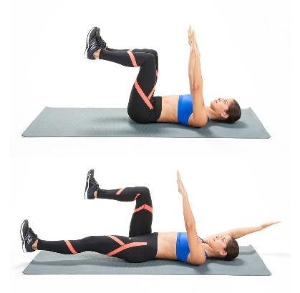
. BICYCLE CRUNCH  https://www.youtube.com/watch?v=eBZ4rdDjLFM | 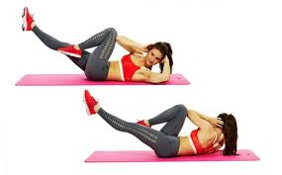
RUSSIAN TWIST  https://youtu.be/JyUqwkVpsi8 | 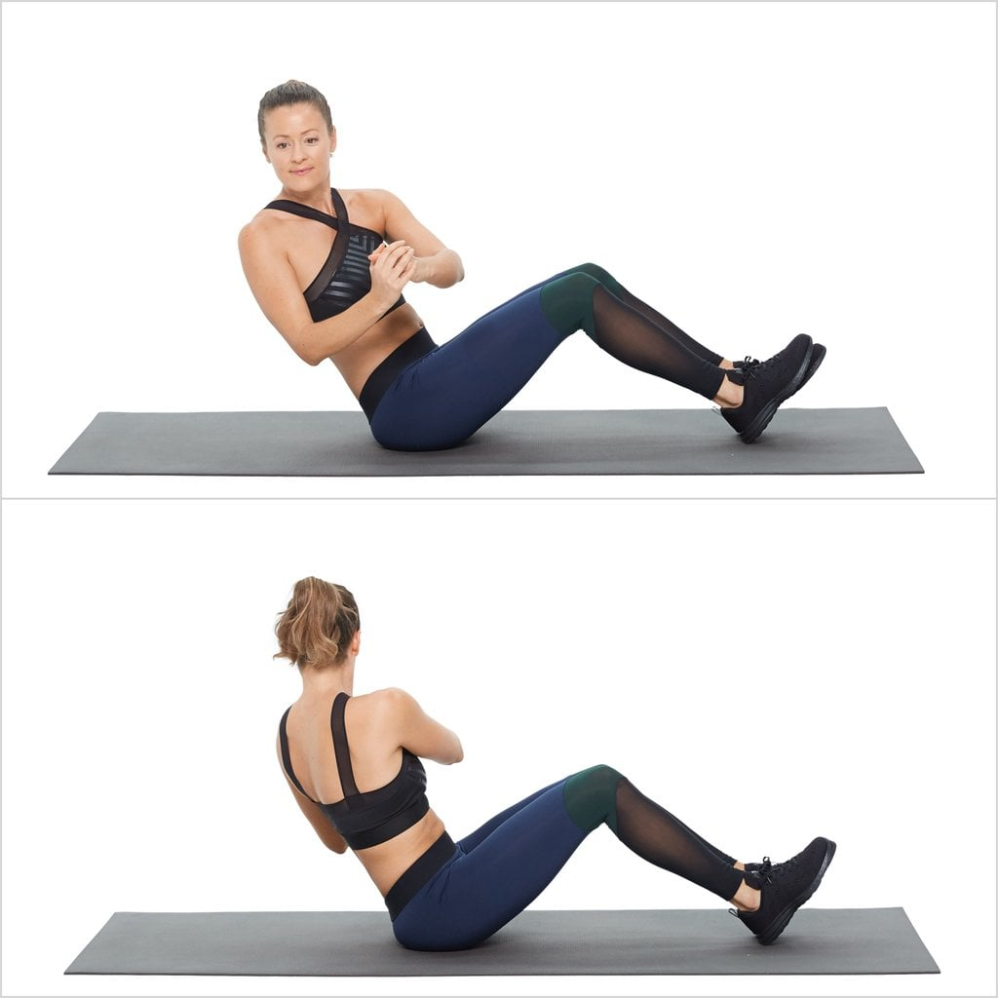
BUTT UPS  https://www.youtube.com/watch?v=_-Ke7ZS8HJc | 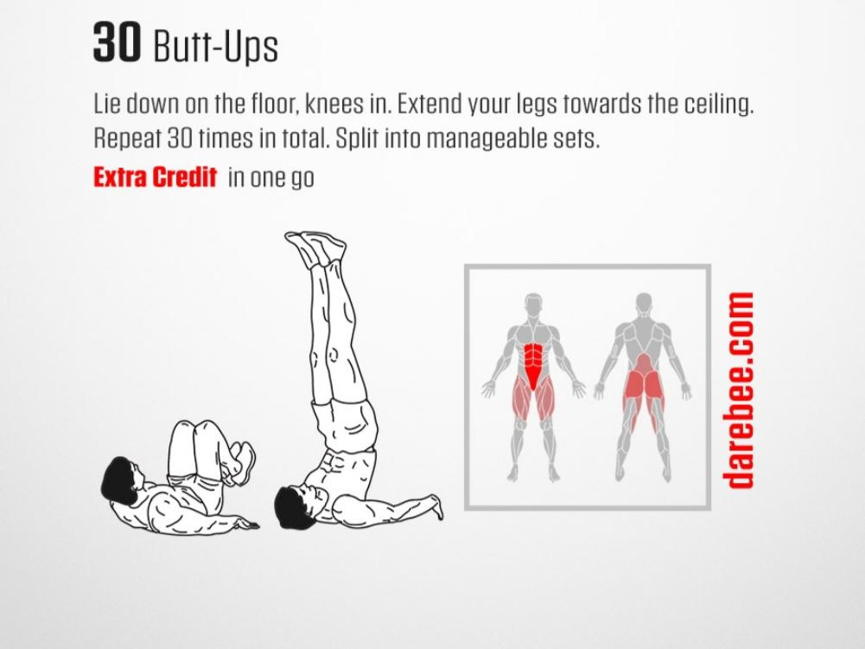
trbušnjaci  https://www.youtube.com/watch?v=Xyd_fa5zoEU | 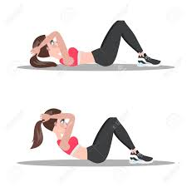
Heel touch  https://youtu.be/RW25fbkQxVQ | 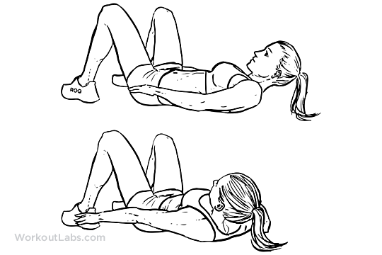
MOUNTAIN CLIMBERS  https://youtu.be/zT-9L3CEcmk | 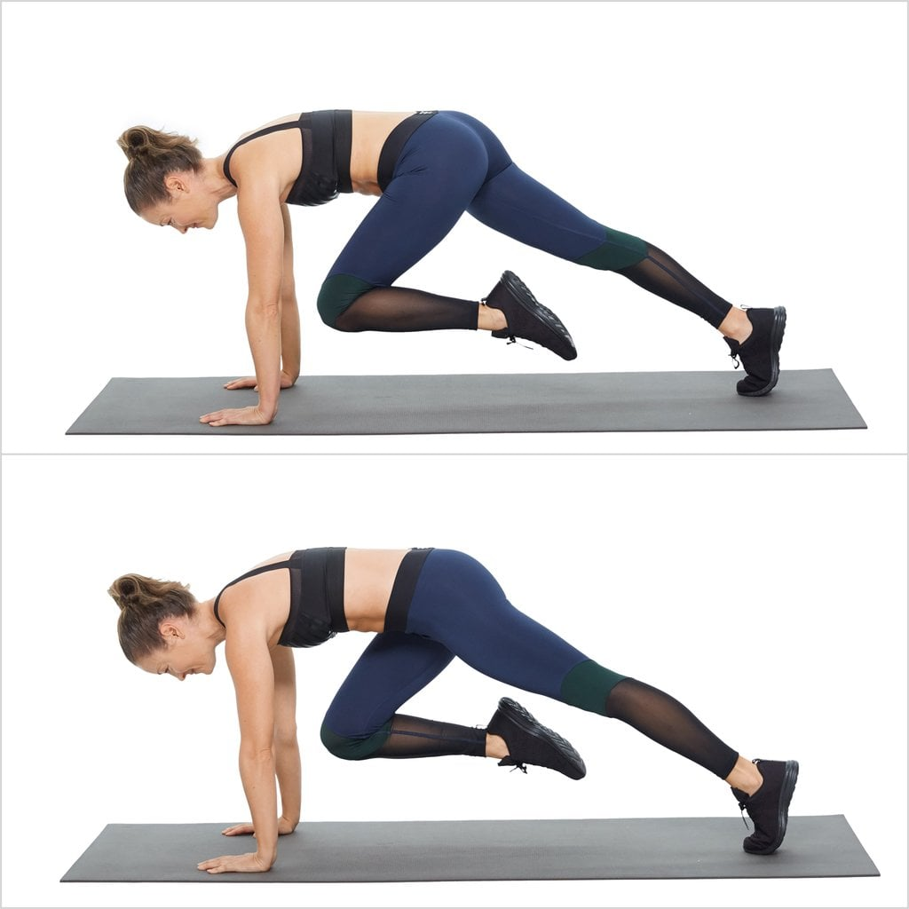
V-crunch  https://youtu.be/5UNy8HdV6jE | 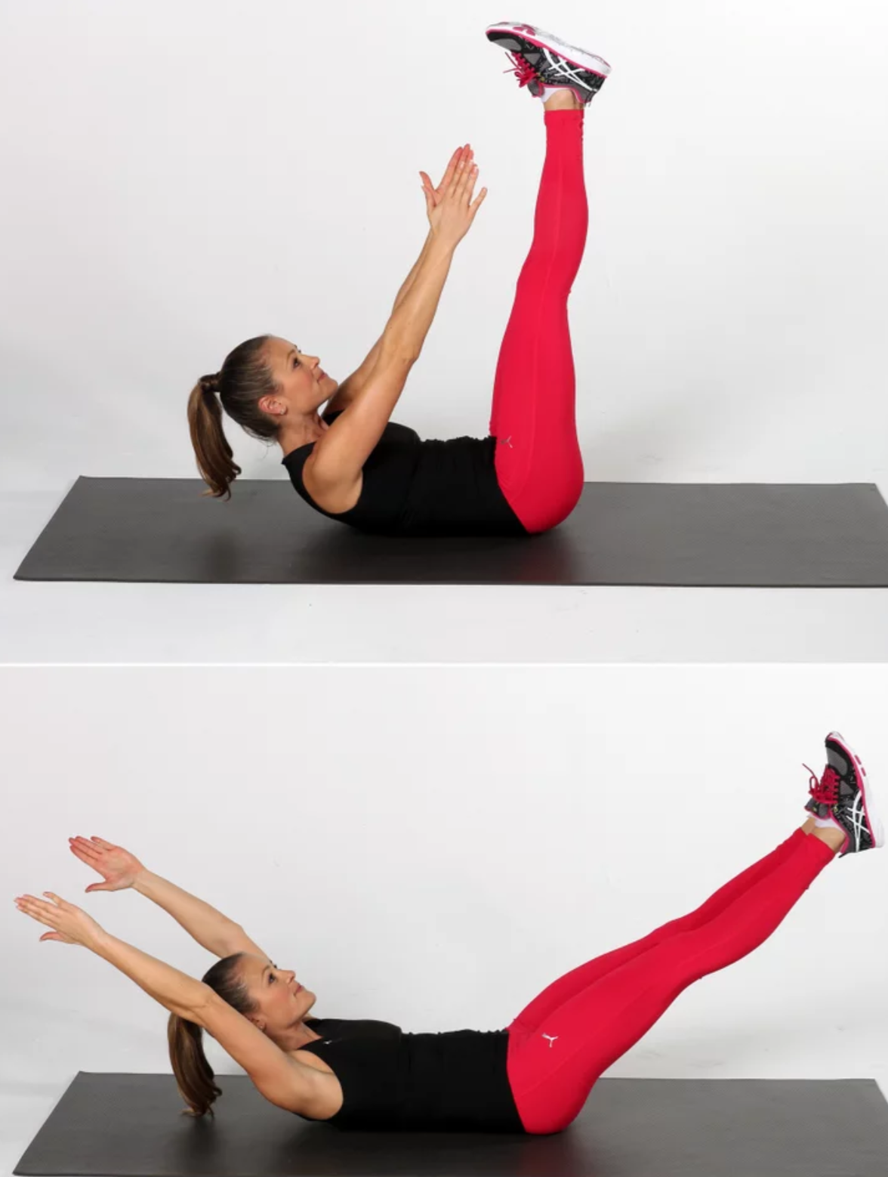
Oblique crunch  https://www.youtube.com/watch?v=98eX0ndm7Z4 | 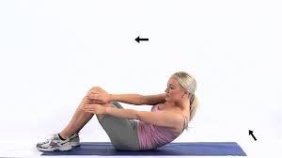
Windshield wipers  https://youtu.be/X59_4RrU_aA | 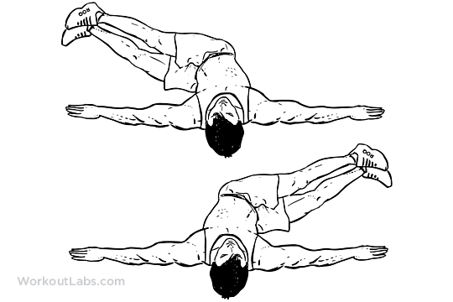
Flutter kicks  https://www.youtube.com/watch?v=BlJQtdcCzeA | 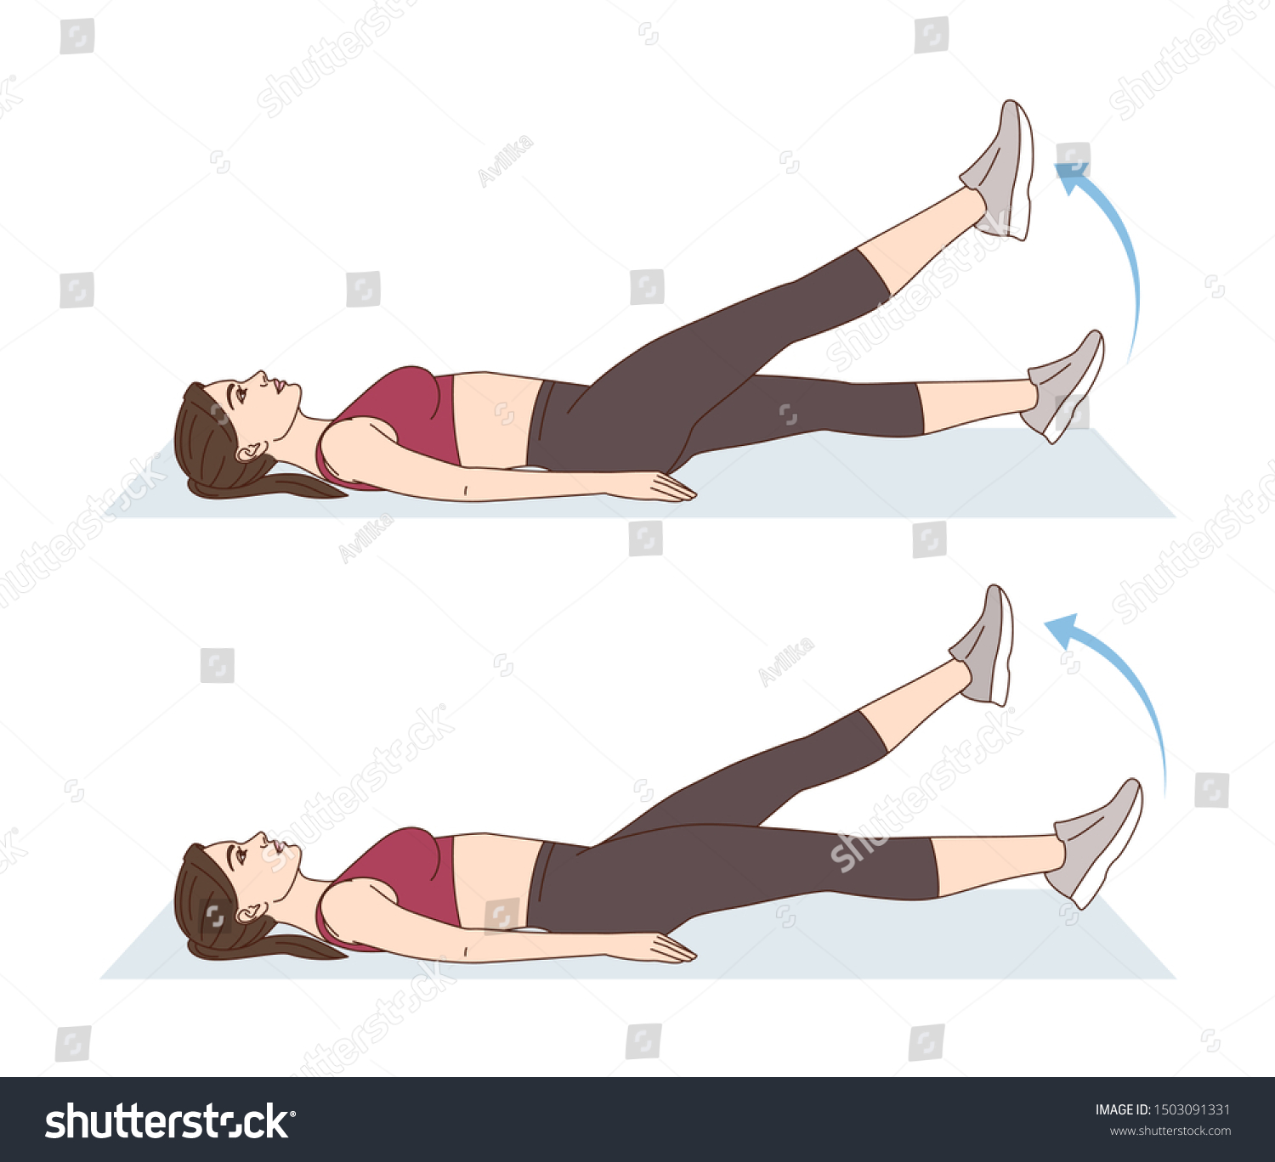
reverse crunch  https://youtu.be/hyv14e2QDq0 | 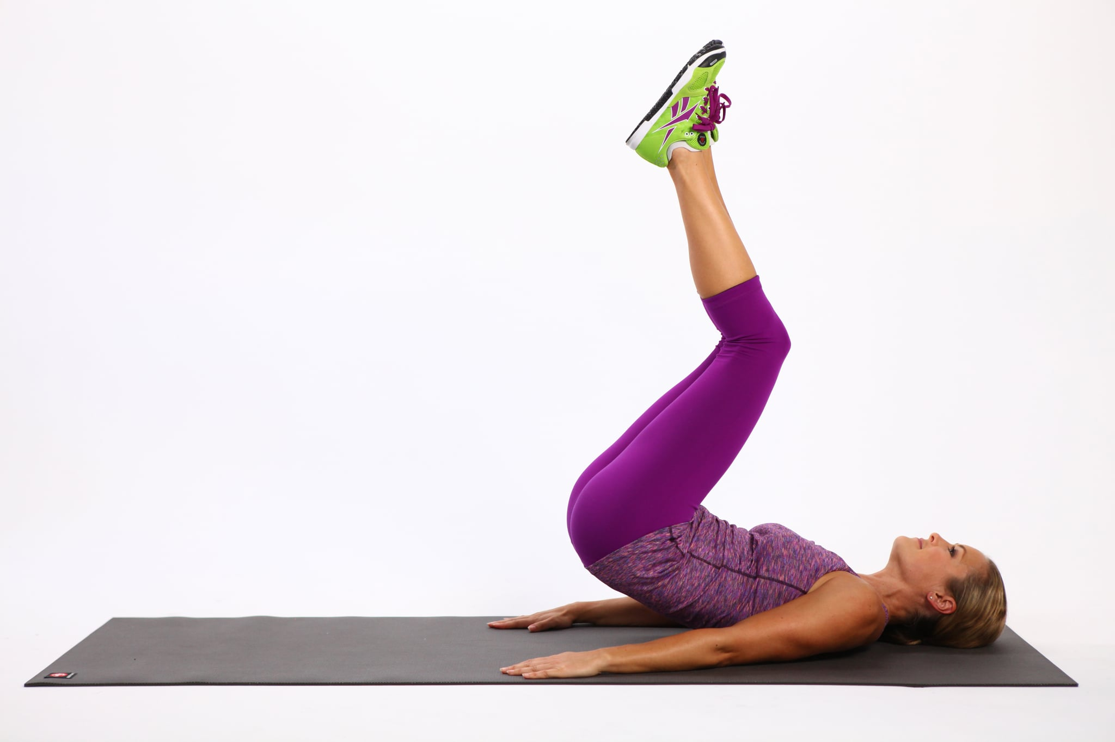
Bočni plank  https://www.youtube.com/watch?v=rzOH2q63SZg | 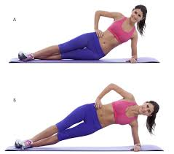
Alternating toe reach  https://www.youtube.com/watch?v=AViC4ZaIYjU | 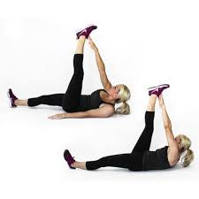
hollow body hold  https://youtu.be/4xRpGgttca8 | 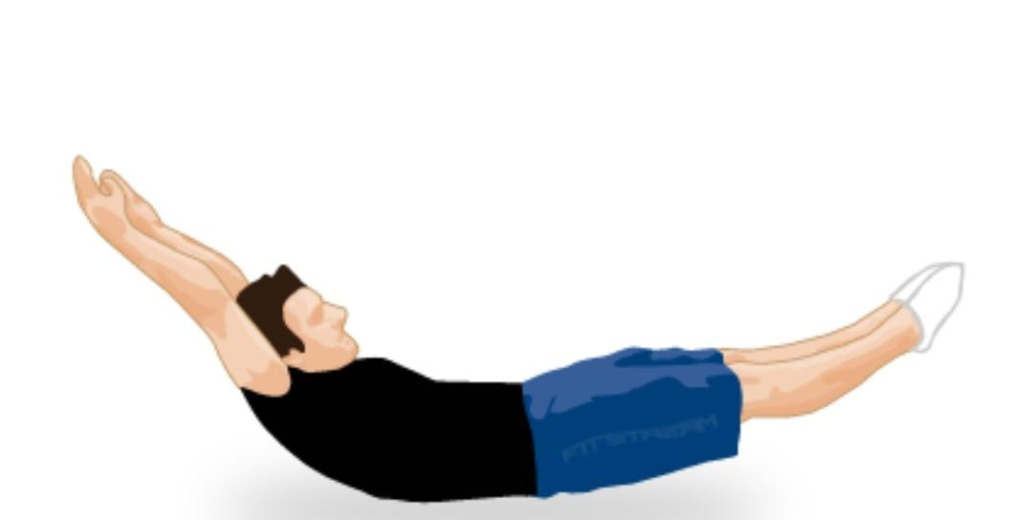
Side Plank and Reach Through  https://www.youtube.com/watch?v=hw5AqMWB-x4 | 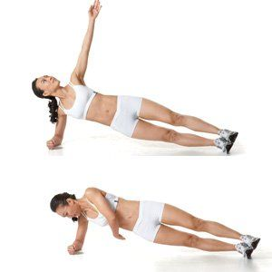

VJEŽBE ZA MIŠIĆE NOGU
( KVADRICEPS – PREDNJA STRANA NATKOLJENICE)
( HAMSTRINGS – STRAŽNJA STRANA NATKOLJENICE )
( GLUTES – MIŠIĆI STRAŽNJICE )
( CALF – MIŠIĆI STRAŽNJE STRANE POTKOLJENICE )

ČUČANJ  https://www.youtube.com/watch?v=aclHkVaku9U | 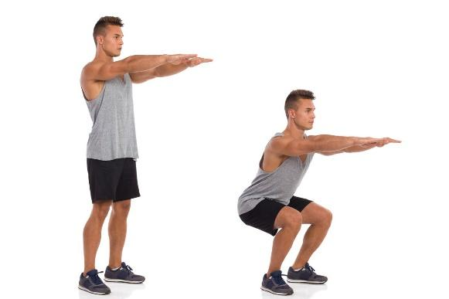
ISKORAK S UTEGOM  https://www.youtube.com/watch?v=sKpO78nSkiA | 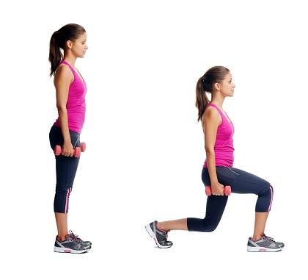
IZDRŽAJ U ČUČNJU (uz zid)  https://youtu.be/-0Q7Lds7B8A | 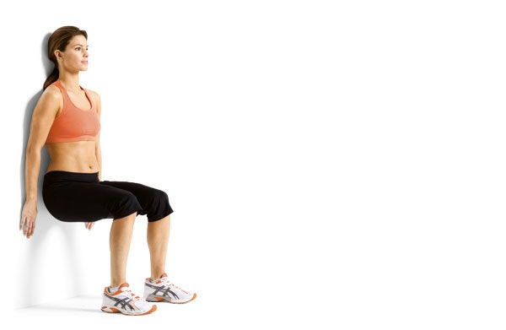
Donkey kicks  https://www.youtube.com/watch?v=SJ1Xuz9D-ZQ&feature=share | 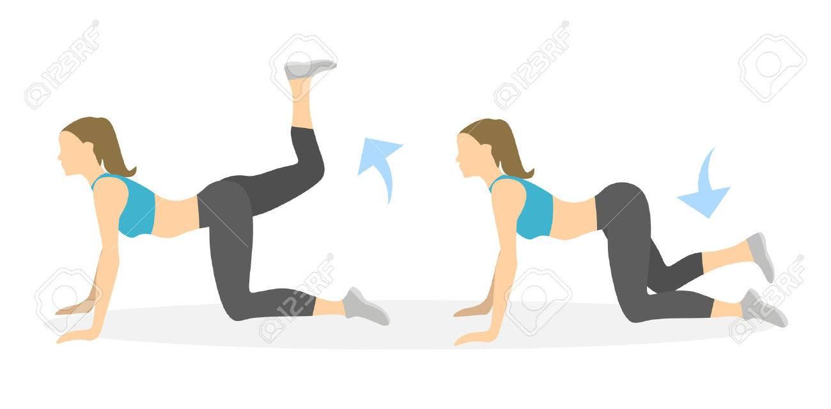
podizanje listova  https://www.youtube.com/watch?v=-M4-G8p8fmc | 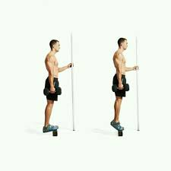
side to side lunges  https://youtu.be/KXoVm0WXcfE | 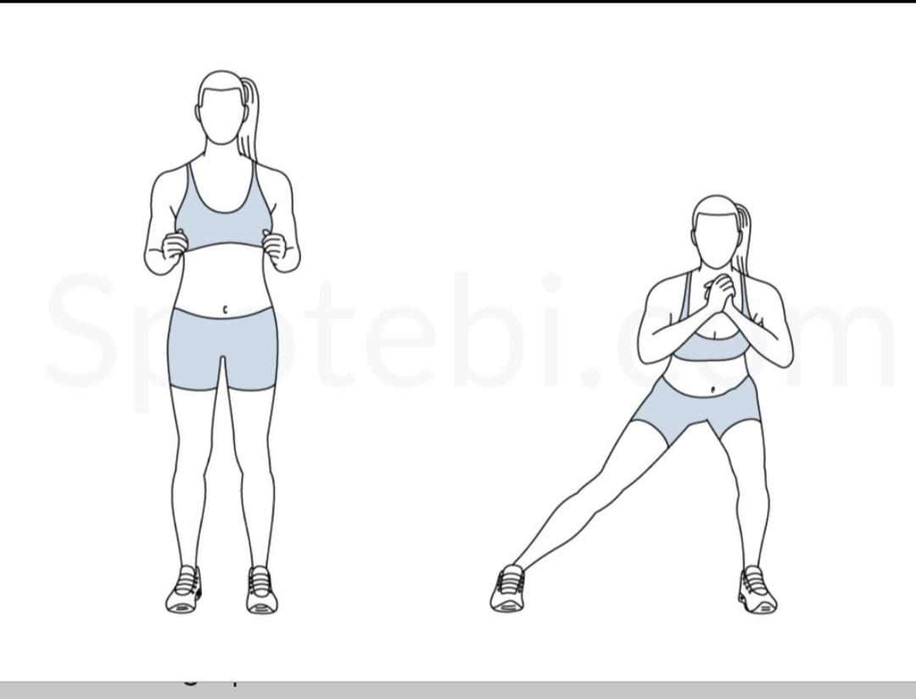
Podizanje peta  https://www.youtube.com/watch?v=MW2WG5l-fYE#action=share | 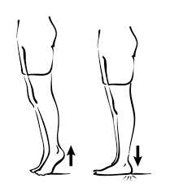
Tabletop to reverse pike  https://youtu.be/G28Lt0A83jM | 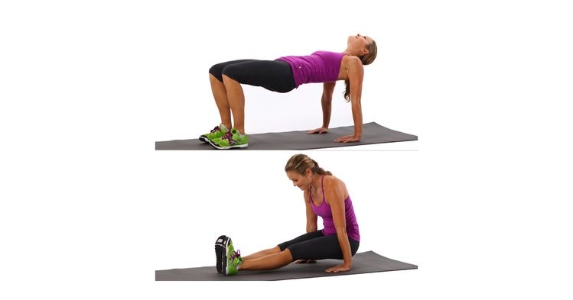
stražnji iskoraci  https://www.youtube.com/watch?v=cr_FSOcN9xs | 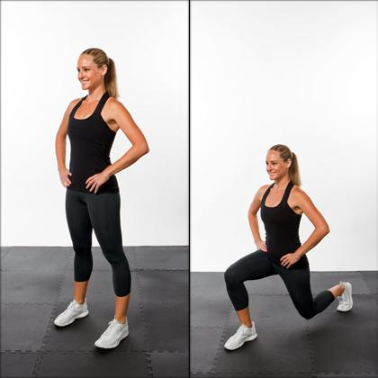
side steps  https://www.youtube.com/watch?v=9VcjsYP32GQ&t=4s | 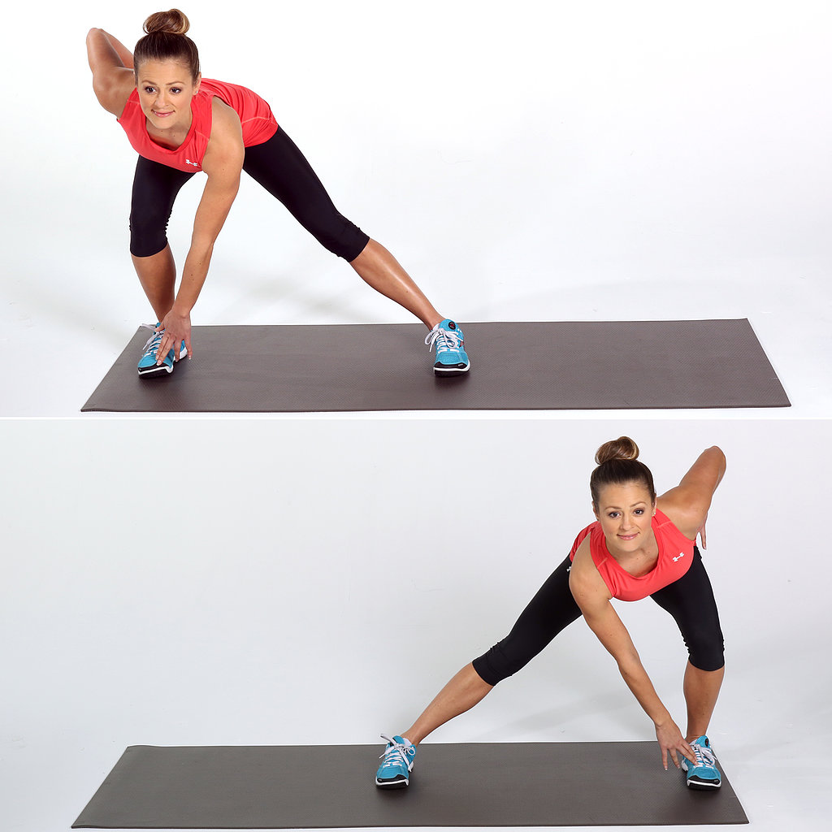
jednonožni čučanj  https://www.youtube.com/watch?v=9_Ca2YRRdtE | 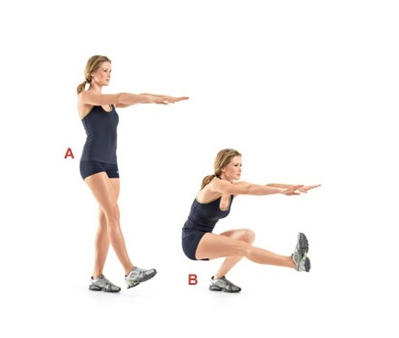
Visoki skip  https://www.youtube.com/watch?v=aL1A_9wfpL8 | 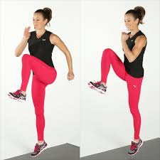
Jednonožni bugarski čučanj  https://youtu.be/sqy-Q3XBAVw | 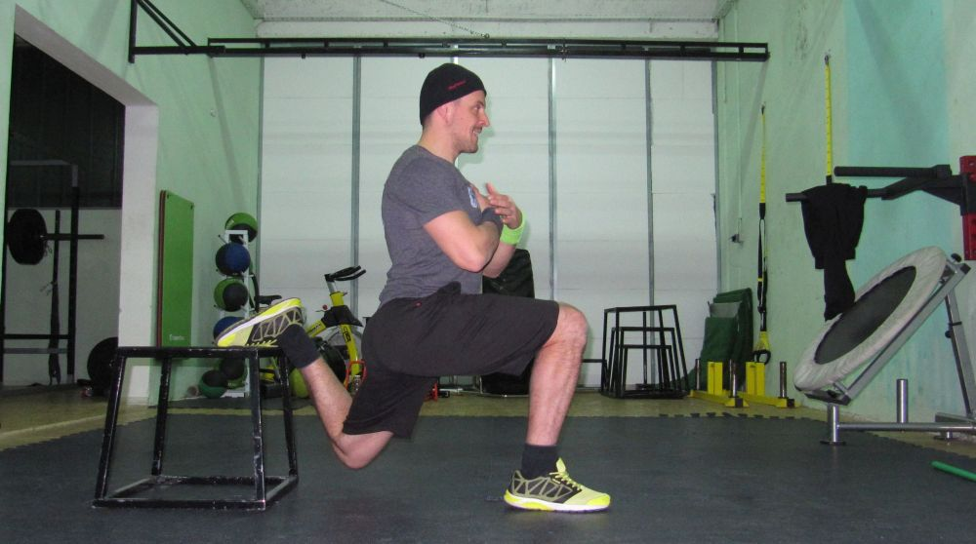
Glute bridge  https://www.youtube.com/watch?v=wPM8icPu6H8&app=desktop | 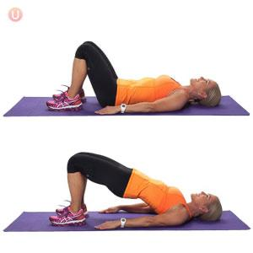
Side squat  https://youtu.be/C0dFeb1v4xw | 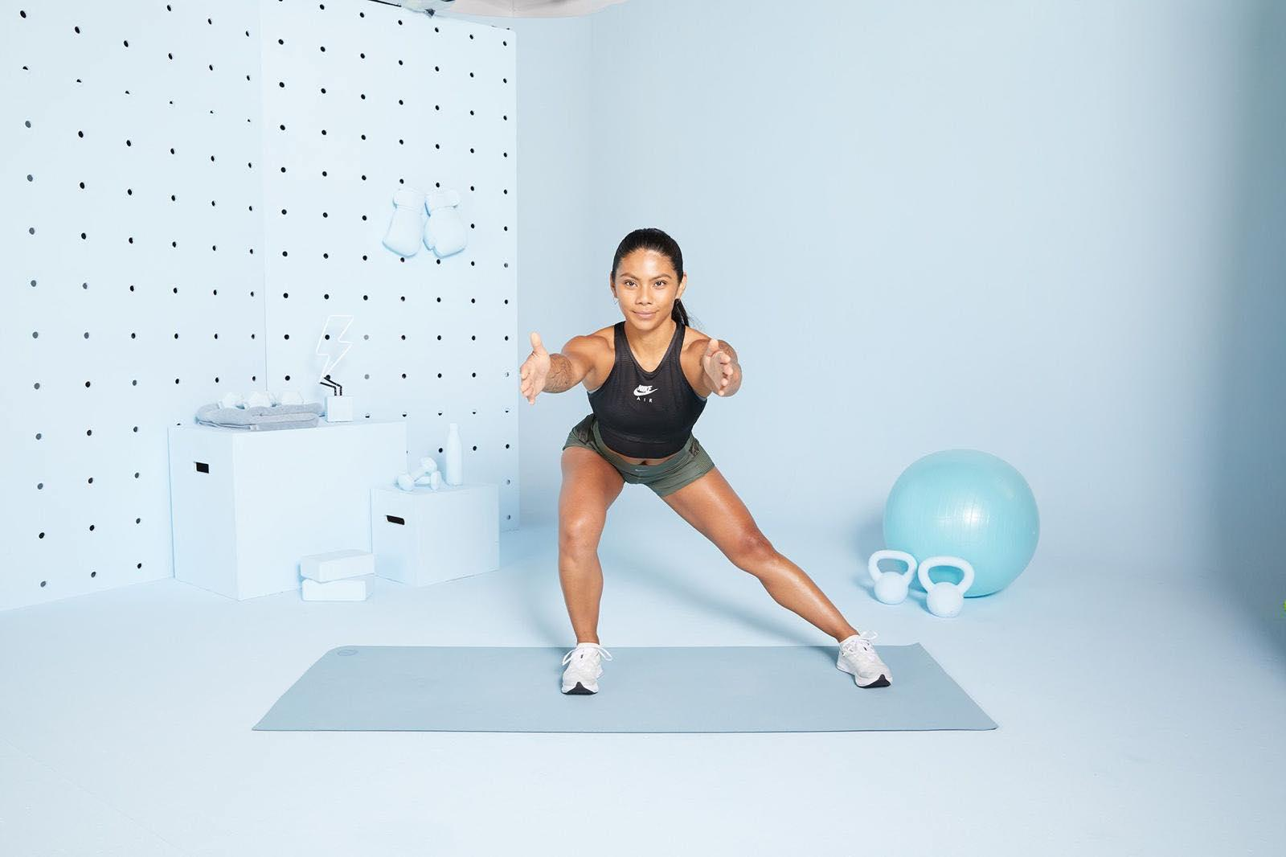
Skok čučanj  https://www.youtube.com/watch?v=sqfQzdbAHcI | 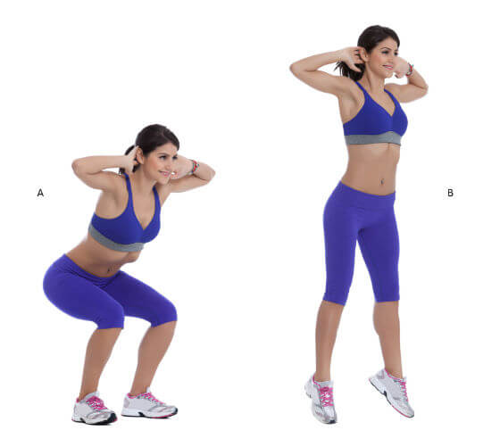
Čučanj s girjom  https://www.youtube.com/watch?v=egguClDivzU | 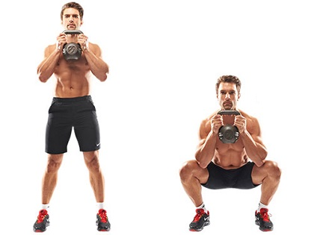

VJEŽBE ZA CIJELO TIJELO

MARINCI  https://www.youtube.com/watch?v=TU8QYVW0gDU | 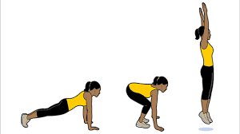
PLANK  https://www.youtube.com/watch?v=1IJp0aPcXtg | 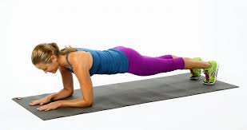
JUMPING JACKS  https://www.youtube.com/watch?v=c4DAnQ6DtF8 | 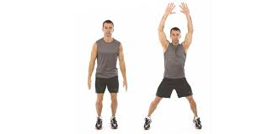
MAN MAKER  https://www.youtube.com/watch?v=2-6EPLtSLwU | 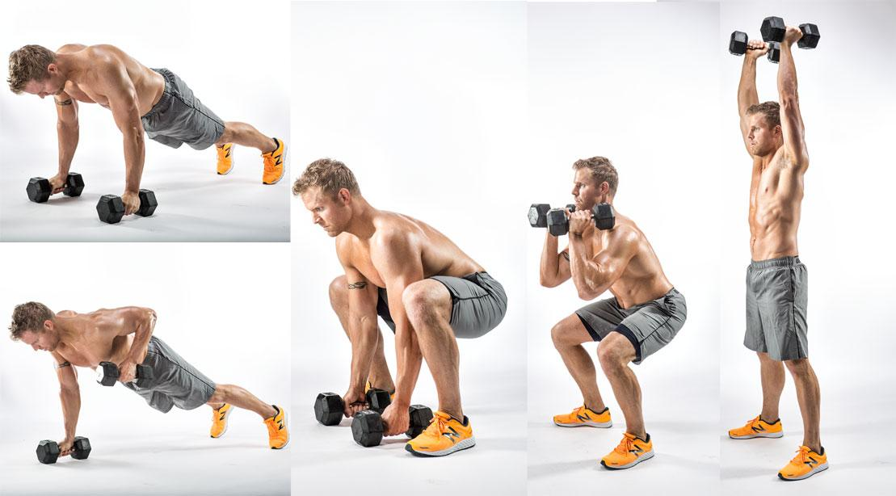

VJEŽBE ISTEZANJA
GORNJI DIO LEĐA | https://www.youtube.com/watch?v=vuGnzLxRvZM
DONJI DIO LEĐA | https://www.youtube.com/watch?v=Xm8iSSdU3I0
KUKOVI | https://www.youtube.com/watch?v=j42sLnoMkrA
MIŠIĆI TRBUHA | https://www.youtube.com/watch?v=D1tzvP8dGR4
MIŠIĆI NOGU | https://www.youtube.com/watch?v=gKtYpCoFYiU
MIŠIĆI RUKU I RAMENOG POJASA, PRSA | https://www.youtube.com/watch?v=VULt--bcWd0
CIJELO TIJELO | https://www.youtube.com/watch?v=flDQ-Av5DZ8  https://www.youtube.com/watch?v=GLy2rYHwUqY  https://www.youtube.com/watch?v=GGJzZx4H2K4

